**Docker Assignment 2**

**You have been asked to:**

● Save the container created in Assignment 1 as a Docker image

● Launch container from this new image and map the port to 81

● Go inside the container and start the apache2 service

● Check if you are able to access it on the browser

**A. Save the container created in Assignment 1 as a Docker image**

**Step 1: Run** this **command** to **convert** the **container** into the **image:**

**“sudo docker commit test assignment2”.**

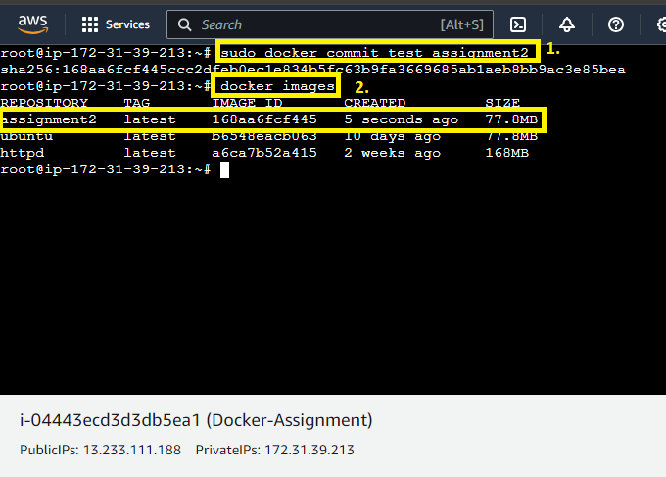

**When you run** the **“docker images” command, you** will **notice** that **“assignment2” image** has been **successfully created.**

**B. Launch container from this new image and map the port to 81**

**Step 1: Run** this **command** to **create a container** & **map into port number 81.**

**sudo docker run –itd –p 81:80 –name test1 assignment2**

**A new container** will be **created & map** on to **port number 81.**

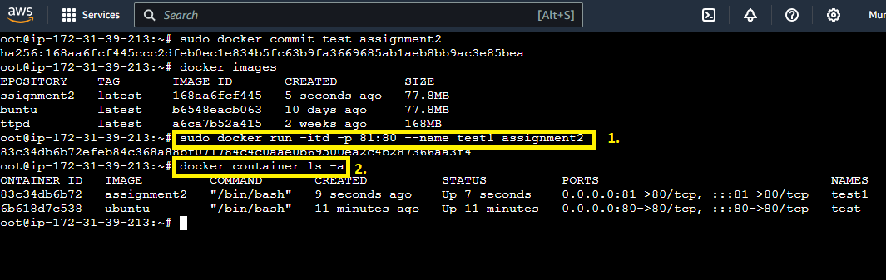

**When you run** the **“docker container ls –a” command,** the **test1 container** is **successfully mapped** on the **port number 81.**

**C. Go inside the container and start the apache2 service**

**Step 1: Run** this **command** to **go inside** into the **container:**

**“sudo docker exec –it test1 bash”.**

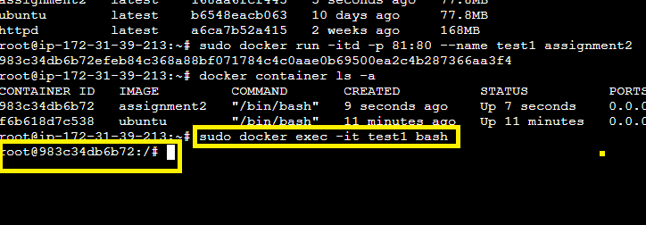

**Step 2: First, run** the **“apt update”** to **update** the **machine.**

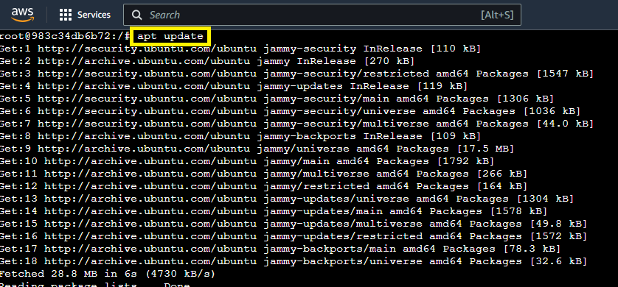

**Step 3: To install** the **“apache2”, use** this **command: “apt install apache2”.**

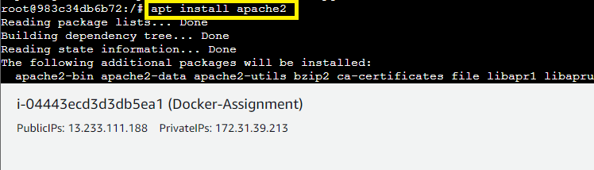

**Step 4: Run** this **command** to **check** that **“Apache2”** is **running or not. [service apache2 status]. The Apache2** is not **running.**

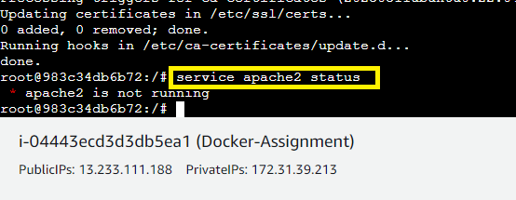

**Step 5: To start** the **apache2, use** this **command: service apache2 start.**

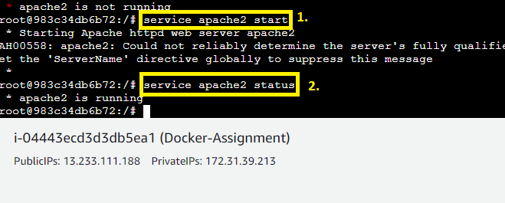

**When you run the command “service apache2 status”. The Apache2** will be **in** the **“Running State”** now.

**D. Check if you are able to access it on the browser**

**Step 1: Go** to the **“Instances” section** & **select** your **instance. Click** on the **“open address”.**

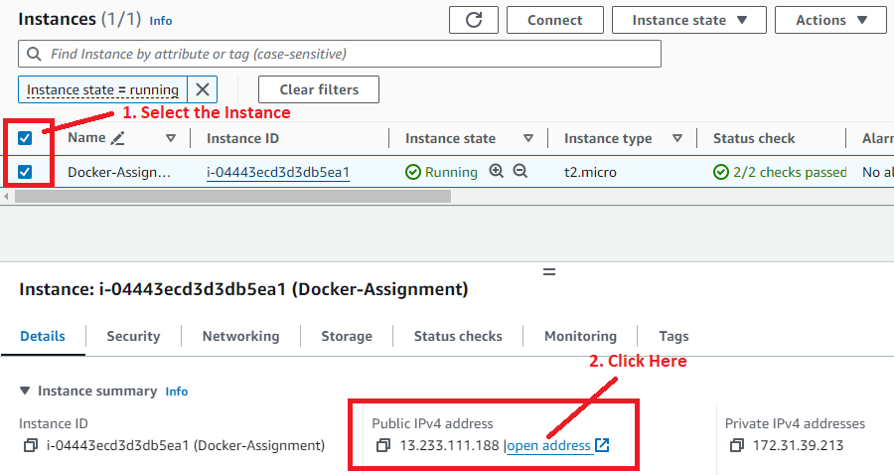

**Step 2: Your Apache2 Web page** will be **successfully opened** on the **port 81.**

